What's changed in DreamGrid in 7.2405
A summary of everything that landed in this release includes new tools, a rebuilt Region List, and a long list of stability and memory fixes.

City Map [NEW]
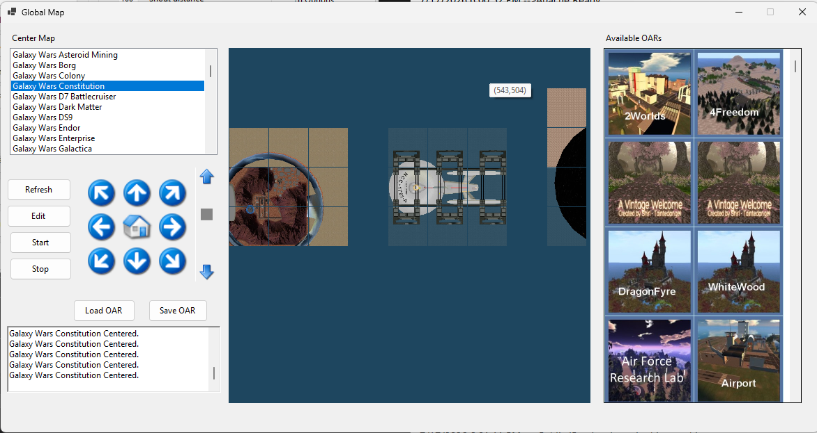
A visual world map for laying out your grid. It shows live map tiles on a zoomable grid of cells, with each region's name and coordinates in place.

- Select a region from the upper left control to center it on the map
- Click a region to select it, including large var regions (2×2 up to 16×16) outline their entire footprint as one box, not just the clicked cell.
- Start, stop, edit, save an OAR, or load an OAR for the selected region without leaving the map.
- Pan with arrow buttons and zoom the view from a single region up to a wide overview.
- Move a region by dragging its tile to any open water cell.
- Drag an OAR from the built-in library onto any cell to load it; dropping on open water creates a new region there first.
- Drag and drop any region on the map to move it.

Region List, rebuilt [IMPROVED]
The Region List's old list controls were replaced with proper sortable grids across all views, including Details, Users, Avatars, and Visitors. In the future we can have checkboxes, pulldowns and text entry.
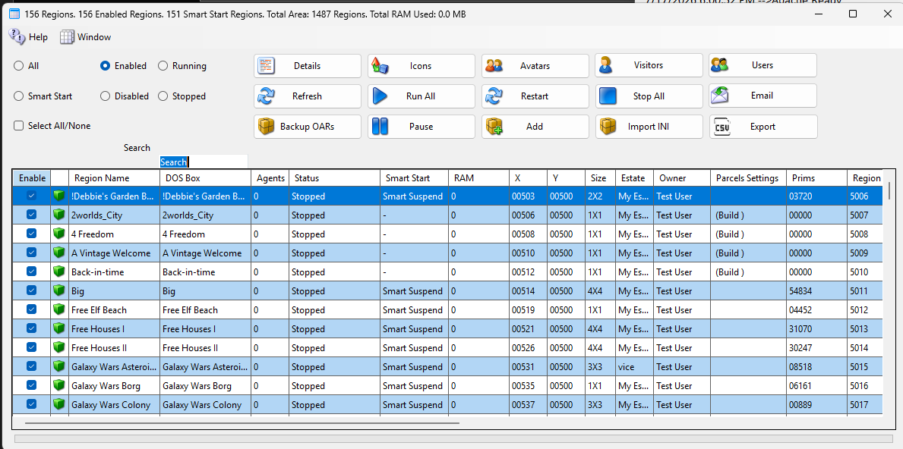
- Much faster. This has been a limit for me as I run 450+ regions to debug speed. Now it takes a few seconds to refresh.
- Click any column header to sort; column widths are remembered between sessions.
- Click a region row for the start / stop / edit / console popup; click an Icon to teleport to the region.
- Click an Avatar and teleport to them in Visitors,
- Select all / none works better and is far faster.
- Fixed a crash when closing the window while a refresh was still running.
- Multi-screen support and DPI awareness.

Speed Improvements in Mysql
DreamGrid detects whether it is installed on an HDD or SSD to launch MySQL at "warp speed." If you have UPS connected to shut down your PC, you can enable it as a service at Ludicrous speed. This changes various MySQL settings for buffering and disk use to avoid swamping MySQL on HDDs and to use RAM as buffers.

Web control panel & API [NEW
The built-in web pages grew into a small remote-control panel for the grid.
Address is http://yourgrid./API or https://yourgrid./API. The document also exposes more API commands plus the ones used to make this control panel. In the future I can replace the old Diva Wifi. The features vary by permissions of each type of user, including a new type - a Grid Owner.
- A password-protected login page guards the API pages.
- The API page was designed for various web controls, is async, JavaScript and if a region row is selected it can be used for stopping starting and restarting regions from a browser.
- Your users will in future updates be able to backup and save their OARs and IARs if you enable it on a per user basis.
- A sortable, searchable Region List page shows what is running. You can enable or disable a region, view its status and start, stop or back them up from a web page.
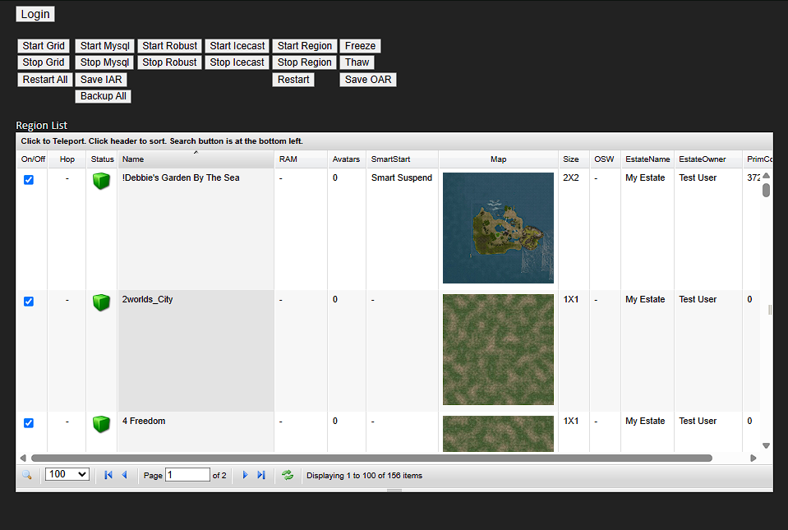

Windows service mode [New]
- MySQL can run as a real Windows service (shown as MysqlService in services.msc), and DreamGrid's own service settings are pushed into the service manager.
- Running DreamGrid in the foreground while the service is active is detected and handled cleanly, and console icons appear in service mode.

Region engine hardening [FIXED]
Did a deep pass over the code that creates, starts, and stops regions, backed by a large unit-test suite so future changes are safer.
- Stopping one region no longer stops all regions in some situations.
- Region .ini files are read and written as UTF-8 now . It protects against hand-edits such as missing-key crashes, causing settings that silently failed to save.
- Port assignments for new regions were repaired so regions cannot be handed duplicate ports.
- The grid occupancy map is now thread-safe and self-healing, and a thread-safety audit fixed several potential races.
- Regions boot faster by getting access to all cores and brief CPU kicks to 100%.
- The region-maker code was reorganized into focused modules.

INVentory tools [NEW]
Xinv, by Balpien Hammerer is a 2024 inventory checker plus an inventory repair function It is integrated into DreamGrid’s Database Settings.
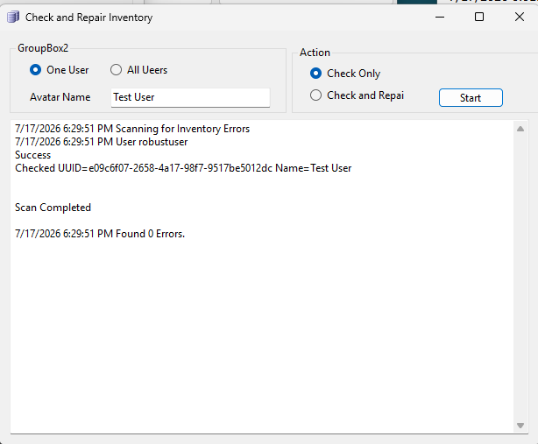

Smaller improvements
- High-DPI awareness and better rendering on modern displays.
- Multi Monitor support
- Most interface text moved into translatable resources, with updated translations.
- MySQL tuning: runtime tuner, refreshed my.ini defaults, connection limit raised for larger grids.
- Fixes for pause behavior, high CPU after boot, a startup crash when a stale PID file pointed at a dead process, and QuickEdit console fixes so an errant click will not pause a region, leading to an eventual, seemingly unrelated crash.
- Text-to-speech announcements handle multi-line messages.
- New v4 build-and-sign pipeline for release packaging, using Microsoft Authenticode signing plus documentation and code cleanup throughout.
- DreamGrid's disk/MySQL now changes config with a CheckDriveType. It tunes MySQL with rules from MySQL Tuner dynamically for SSD/HDD/SCM non-volatile memory.
- Webserver Changes
Apache updated from 2.4.59 to 2.4.68 - mostly security and bugfixes.
Many small changes in Apache config files to modernize syntax.
Removed a certificate for SSL that is not needed any more,
Security protocols bumped TLS 1.2 and 1.3.
- Icecast is now updated to 2.5.0.
- Apache upgraded to 2.4.68, with security tweaks to the web server. Icecast has also been updated, along with many core DLLs to the latest, most secure code.
- Added a Crash Counter for fatal errors, so now 3 retries will occur and the system will stop and wait for user intervention. This is to prevent a crash loop from happening.

- Balpien Hammerer's 2024 version of Xinv.php "inventory repair" is now fully integrated. Very nice program!
Look in Setting->Database and run the new Repair Inventory button for a report. This can also repair items. I have found many issues with this in my old grid which is about 16 years old.
So far it has successfully found and repaired
Missing Suitcase folder - repairs this
Root folder missing - needs adding manually as cannot repair
Warning: UUID=XXX does not exist in table - warning
Old type 9 root found, converted to type=8 - repairs this
Root parent folder ID was wrong, should be null key - repairs this
- Global Search is back online after a major crash in my webserver. It killed downloads and updates. The amounts vary, but last time I looked about 8,000 free objects are a click away. The system is now in multiple places in a datacenter and a new faster webserver is running it all.
- New server for Outworldz.com Grid has arrived: a Ryzen 7, 16 Cores, 64 GB.
- This has no impact on operations of your grid. My free custom DYN DNS is dual-redundant at two different Windows Datacenter servers.

Every change above ships in the regular DreamGrid updater, and no manual steps are needed. Regions, settings, database and backups as always, are untouched by the upgrade.
DreamGrid by Fred Beckhusen / Outworldz, LLC>

